# **Hamlyn Home Office Desk with Chair and Storage**

**Details & Overview $1,079.96**

**Description**

Simply exquisite, this striking home office set blends stately, traditional style with a European flair. An antiqued finish adds Old World character—while a drop-down drawer front concealing pull-out keyboard tray is a modern convenience. Along with the file cabinet that also features convenient casters, the chair offers tilt, swivel and adjustable height mechanisms for customized comfort. Add in a three-shelf bookcase and you’ll have a home office that works for you.

* Includes desk, file cabinet, medium bookcase and swivel chair
* Desk, file cabinet and bookcase made of veneer, wood and engineered wood
* Swivel chair made of wood and engineered wood with faux leather upholstery
* Hand-finished
* Antiqued bronze-tone hardware
* File cabinet and chair with metal and plastic casters
* Desk with drop-down keyboard tray
* File cabinet with 1 drawer and 1 file drawer
* Bookcase with 3 adjustable shelves
* Assembly required

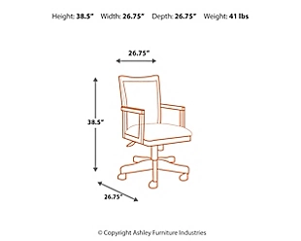**Weight**

246 lbs. (111.58 kgs.)

**Dimensions**

* Width: 48.00"
* Depth: 28.00"
* Height: 30.13"

**Additional Dimensions**

* Adjustable seat height (min): 17.75"
* Adjustable arm height (min): 24.88"
* Distance between arms: 19.25"
* Adjustable chair height (max): 38.38"
* Adjustable chair height (min): 35.25"
* Adjustable seat height (max): 21.13"
* Adjustable arm height (max): 28.00"
* Apron to floor: 24.75"
* Drop-down keyboard tray Width: 25.63"
* Drop-down keyboard tray Depth: 15.06"
* Drop-down keyboard tray Height: 1.75"
* Top drawer interior Width: 12.13"
* Top drawer interior Depth: 16.25"
* Top drawer interior Height: 3.88"
* Bottom drawer interior Width: 12.00"
* Bottom drawer interior Depth: 16.38"
* Bottom drawer interior Height: 10.25"
* Opening Width: 29.38"
* Opening Depth: 9.94"
* Opening Height: 47.13"
* Adjustable shelf (3) Width: 32.38"
* Adjustable shelf (3) Depth: 9.88"
* Adjustable shelf (3) Height: 1.63"